**Week 5 Ex-11-Output**

**1. Actuator Health Endpoint.  
**

**2. Actuator Metrics Endpoint.**  
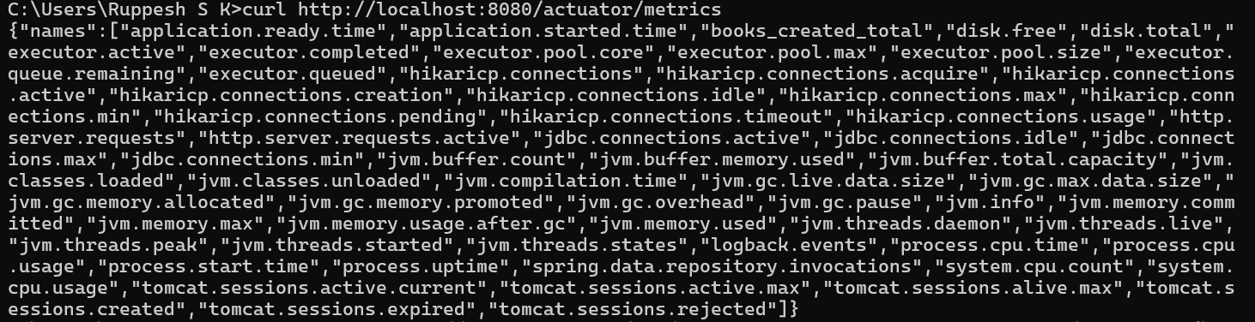

**3. Create a Book:  
  
  
  
4.** **Get Details for Custom Metric.  
**